 | [CEL 324] Computer Organization & Assembly Language
 | BSCS - 3rd SEMESTER
Lab 06: Logical Instructions

Objective:
To be familiar with the Logical instructions.
Theory:
In this Lab, the four basic operations of boolean algebra: AND, OR, XOR, and NOT are introduced. These operations can be carried at the binary bit level, using assembly language instructions. These operations are also important at the boolean expression level, in IF statements, for example.The techniques used here could be used to manipulate control bits for hardware devices, implement communication protocols, or encrypt data, just to name a few applications. The Intel instruction set contains the AND, OR, XOR, and NOT instructions, which directly implement boolean operations on binary bits, shown in the Table 7.1.

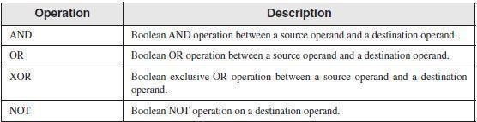
Table 7.1

The CPU Flags
Boolean instructions affect the Zero, Carry, Sign, Overflow, and Parity flags.
•The Zero flag is set when the result of an operation equals zero.
•The Carry flag is set when an operation generates a carry out of the highest bit of the destination operand.
•The Sign flag is a copy of the high bit of the destination operand, indicating that it is negative If set and positive if clear. (Zero is assumed to be positive.)
•The Overflow flag is set when an instruction generates an invalid signed result.
•The Parity flag is set when an instruction generates an even number of 1 bits in the low byte of the destination operand
38

AND Instruction
The AND instruction performs a boolean (bitwise) AND operation between each pair of matching bits in two operands and places the result in the destination operand: AND destination,source The following operand combinations are permitted:
AND reg,reg AND reg,mem AND reg,imm AND mem,reg AND mem,imm

The operands can be 8, 16, or 32 bits, and they must be the same size. For each matching bit in the two operands, the following rule applies: If both bits equal 1, the result bit is 1; otherwise, it is 0. The AND instruction lets you clear 1 or more bits in an operand without affecting other bits. The technique is called bit masking, much as you might use masking tape when painting a house to cover areas (such as windows) that should not be painted. Suppose, for example, that a control byte is about to be copied from the AL register to a hardware device. Further, we will assume that the device resets itself when bits 0 and 3 are cleared in the control byte. Assuming that we want to reset the device without modifying any other bits in AL, we can write the following: and AL,11110110b ; clear bits 0 and 3, leave others unchanged
For example, suppose AL is initially set to 10101110 binary. After ANDing it with 11110110, AL equals 10100110:
mov al,10101110b
and al,11110110b ; result in AL = 1010 0110

OR Instruction
The OR instruction performs a boolean OR operation between each pair of matching bits in two operands and places the result in the destination operand:
OR destination,source
The OR instruction uses the same operand combinations as the AND instruction: OR reg,reg
OR reg,mem OR reg,imm OR mem,reg OR mem,imm

The operands can be 8, 16, or 32 bits, and they must be the same size. For each matching bit in the two operands, the output bit is 1 when at least one of the input bits is 1.
The OR instruction is particularly useful when you need to set 1 or more bits in an operand without affecting any other bits. Suppose, for example, that your computer is attached to a servo motor, which is activated by setting bit 2 in its control byte. Assuming that the AL register contains a control byte in which each bit contains some important information, the following code only sets the bit in position 2.
or AL,00000100b ; set bit 2, leave others unchanged

39

XOR Instruction
The XOR instruction performs a boolean exclusive-OR operation between each pair of matching bits in two operands and stores the result in the destination operand: XOR destination,source

The XOR instruction uses the same operand combinations and sizes as the AND and OR
ins tructions. For each matchin g bit in t he two operands, the fo llowing appl ies : If both bits are the same (both 0 o r both 1 ), the result is 0; otherwise, the result is 1. The foll owing tr uth table describes the boolean expression x⊕y:
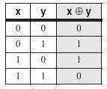
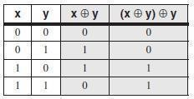
A bit exclusive-ORed with 0 retains its value, and a bit exclusive-ORed with 1 is toggled (complemented). XOR reverses itself when applied twice to the same operand. The following truth table shows that when bit x is exclusive-ORed with bit y twice, it reverts to its original value:
NOT Instruction
The NOT instruction toggles (inverts) all bits in an operand. The result is called the one s om l m t.
The following operand types are permitted: NOT reg
NOT mem
For example, the one’s complement of F0h is 0Fh: mov al,11110000b
not al ; AL = 00001111b
Flags: No flags are affected by the NOT instruction.

Procedure:
Start Emu8086 by selecting its icon.

Write the following codes in the text editor Fill the observation tables accordingly

Program 01:
org 100h
MOV AL, 'a' ; AL = 01100001b
AND AL, 11011111b ; AL = 01000001b ('A')
RET FLAGS

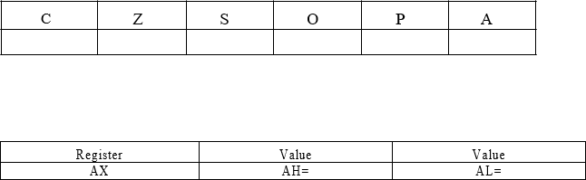

C | Z | S | O | P | A

Program 02:
Register | Value
AX | AH=

org 100h
MOV AL, 'A' ; AL = 01000001b
OR AL, 00100000b ; AL = 01100001b ('a') RET
FLAGS

C | Z | S | O | P | A

Register | Value | Value
AX | AH= | AL=

Program 03:

org 100h
MOV AL, 00011011b
NOT AL ; AL = 11100100b RET

Register | Value | Value
AX | AH= | AL=

Exercise:

Exercise 01

In the following instruction sequence, show the resulting value of AL where indicated, in binary:

MOV AL,01101111b AND AL,00101101b

MOV AL,6Dh AND AL,4Ah

MOV AL,00001111b OR AL,61h

MOV AL,94h XOR AL,37h

43

Exercise 02

Write a single instruction using 16-bit operands that clears the high 8 bits of AX and does not change the low 8 bits.

Exercise 03

Write a single instruction using 16-bit operands that sets the high 8 bits of AX and does not change the low 8 bits.

Exercise 04

Modify Program 01 to store two 16-bit values in AX and BX register and perform AND operation.

Exercise 05
Modify Program 02 to store two 16-bit values in AX and BX register and perform OR operation.

Exercise 06

Modify Program 04 to store two 16-bit values in AX and BX register and perform XOR operation.

44

